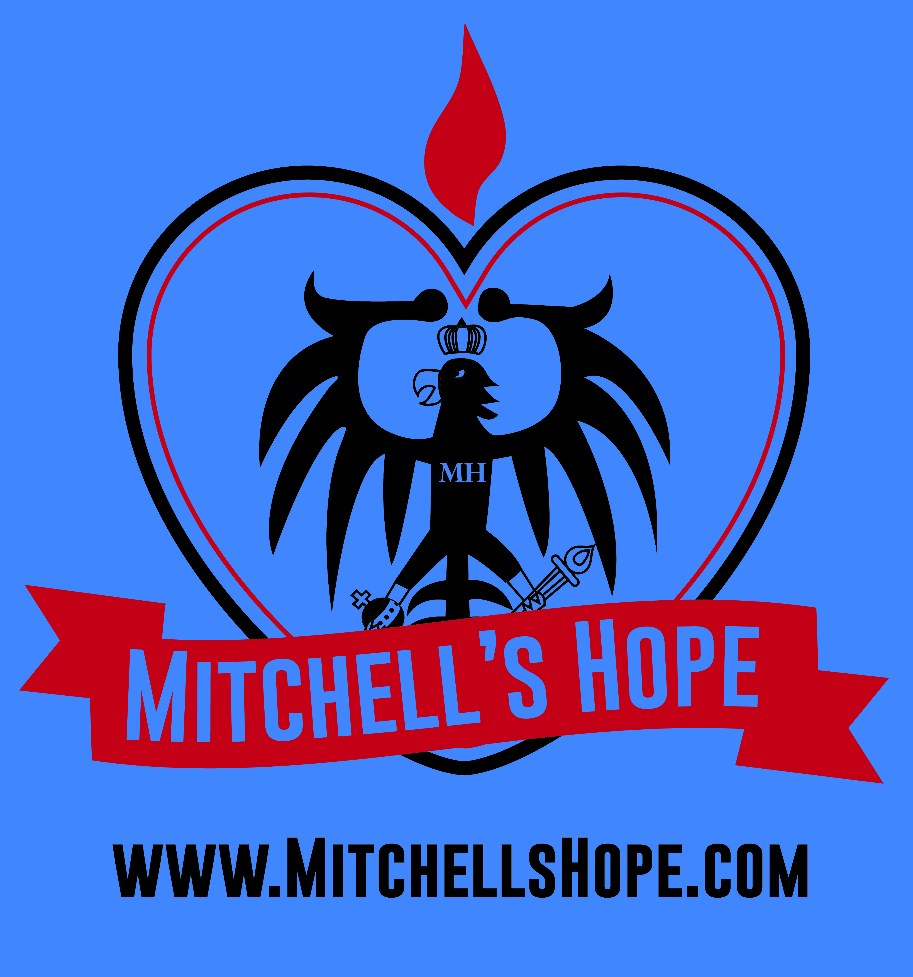
MITCHELL’S HOPE
10133 Samantha Dr.
Fowlerville MI, 48836
(517) 775-5600
www.mitchellshope.com
https://www.facebook.com/mitchshope

Dear Friends, Greetings.
Mitchell’s Hope is organizing an event in observance of National Prevention Week. Our organization’s mission is to bring awareness to the growing epidemic sweeping our nation, killing our children and devastating lives. National Prevention Week, May 17–23, 2015, is a SAMHSA (Substance Abuse and Mental Health Services Administration) supported, national health observance dedicated to increasing public awareness of, and action around, substance abuse and mental health issues.
I am writing this letter to invite you to be a Co-Sponsor or Supporter of this event! As a leader in the community, your involvement with us in National Prevention Week is an opportunity for your organization to receive exposure and to join other individuals, organizations, and coalitions in our community to educate youth and parents about behavioral health issues, promote prevention efforts, and create and strengthen community partnerships. The theme of National Prevention Week 2015 is “The Voice of One, the Power of All.” In keeping with this theme, we will be highlighting the important role each individual and organization in our community has in maintaining a healthy life and ensuring a productive future.
In observance of National Prevention Week, Mitchell’s Hope will be holding a community event (Saturday, May 23 noon-dusk) at Fowlerville Centennial Park. The purpose of this event is to bring people together for a fun filled day while spreading awareness and educating our friends within our community.
Community sponsors are the primary source of funding of this event and will help ensure its success. You can provide support in the following ways:
- Be a Co-Sponsor or Event Supporter through a monetary donation. Your company logo will be placed on materials to promote the event and on posters/flyers day of event.
- Donate: bottled water, food items; subs, pizza etc., paper plates, utensils, bottles or cans of pop or juice, printer paper, services, gift certificates etc.
- Participate on our planning committee for future events.
- Volunteer at the event.
- Sponsor/host an event at your facility.
- Provide information to clients or patrons about the daily themes of National Prevention Week.
Enclosed is a Sponsorship Form that gives information on sponsorship levels. Beyond your sponsorship, we welcome you to join us by participating in our efforts during National Prevention Week. We look forward to hearing from you. For more information about this event, please contact: Michele L. Wagner (517) 775-5600, mitchellshope@gmail.com or Sharon Wagner (517) 775-5500 or by going to our website www.mitchellshope.com
On behalf of Mitchell’s Hope, we thank you for your support.
Sincerely,
Michele L Wagner,
Founder of Mitchell’s Hope
Enclosure: Sponsorship Form
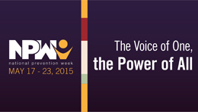
Event Sponsorship Form
MITCHELL’S HOPE; a community event
MAY 23, 2015

Please consider the following ways you can make our efforts
During NPW a success!
Deadline for sponsorship: May 19, 2015

Corporate Sponsor $500
THANK-YOU AD IN LOCAL NEWSPAPER, ACKNOWLEDGMENT ON ORGANIZATION WEBSITE AND/OR SOCIAL MEDIA PROFILES
Added to list of sponsors on day of event and all events for a year
2 free tee-shirts and 2 shirts or hoodies at half price
Corporate Sponsor $1,000 (everything included with $500 sponsor)
-Company name/logo displayed at all events Mitchell’s Hope attends or hosts for one year
-Company name on shirt sleeves worn for International
Overdose Awareness day August 31, 2015

Event Supporters

THANK-YOU AD IN LOCAL NEWSPAPER, ACKNOWLEDGMENT ON ORGANIZATION WEBSITE AND/OR SOCIAL MEDIA PROFILE & ADDED TO LIST OF SPONSORS/SUPPORTERS DAY OF EVENT
$300+ 2 free tee-shirts $250+2 half priced tees
$100 $75
$50

[ ] Become a corporate sponsor or event supporter
[ ] Sponsor donations of less than $50 or donations of goods or services
[ ] Participate on planning committee
[ ] Volunteer at event
[ ] Sponsor/Host event at your facility
---------------------------------------------------------------------------------------------------------------------------------
Business Name: ________________________________________________________________________
Contact Name: _________________________________________________________________________
Contact Phone: _________________________________________________________________________
Contact E-mail: _________________________________________________________________________
Please e-mail your company artwork to mitchellshope@gmail.com
Please fill out this completed sponsorship form today or e-mail it to mitchellshope@gmail.com
Donations of prizes or services are welcome, too. We gladly accept any items you are able to provide.
If interested in becoming a Corporate Sponsor of over $1,000 please contact us so we can provide you details on exactly how we will spend your money e.g. sending representatives to Washington D.C. in October or having your company name and logo promoted on all gear for Mitchell’s Hope for a year. We want to hear from you. Please visit our website to learn more about how Mitchell’s Hope got started.

